Assignment no 8

1) Assume each salesperson has a 12% commission. Write a query on the orders
table that will produce the order number, the salesperson number, and the amount
of the salesperson’s commission for that order.
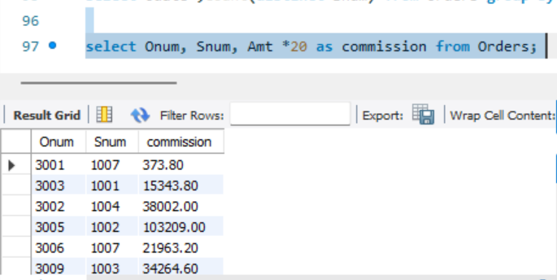
2) Write a query on the Customers table that will find the highest rating in each city.
Put the output in this form:
For the city (city), the highest rating is : (rating).
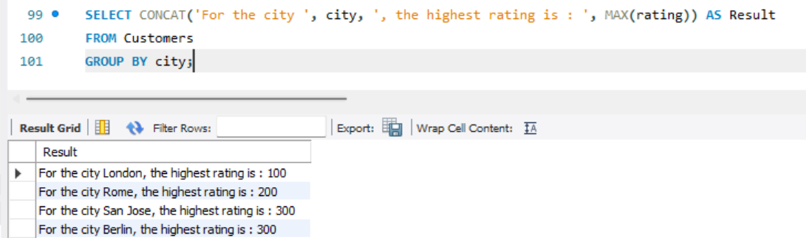
3) Write a query that lists customers in descending order of rating. Output the rating
field first, followed by the customer’s name and number.
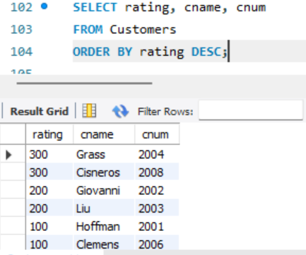
4) Write a query that totals the orders for each day and places the results in
descending order.
